CS 005: Winter 2012

Instructor: Dr. Eamonn Keogh.
eamonn@cs.ucr.edu
Office 318, Winston Chung Building (formally EBII)
Class Web Page: www.cs.ucr.edu/~eamonn/cs005
Office Hours: Open door policy (or by appointment)

Lecture MWF 08:10 a.m. - 09:00 a.m. in BRNHL A125

Labs (you must be enrolled in one of these labs)

- LABORATORY F 11:10 a.m. - 02:00 p.m. ENGR2 133 (Shokoohi-Yekta)
- LABORATORY F 02:10 p.m. - 05:00 p.m. ENGR2 133 (Shokoohi-Yekta)

Teaching assistant:
- Mohammad Shokoohi-Yekta

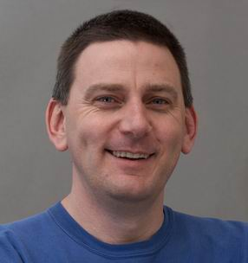  Eamonn Keogh |  | 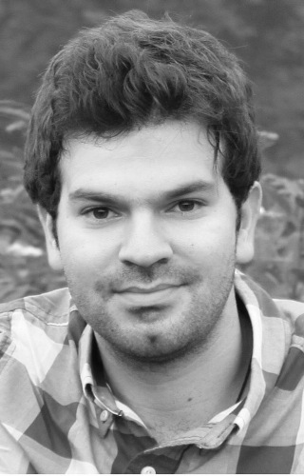  Mohammad Shokoohi-Yekta

Course Description:
CS 005 Introduction to Computer Programming, 4 units, Lecture, 3 hours; laboratory, 3 hours. An introduction to computer programming for nonengineering and nonscience majors and for students considering taking CS 010 but needing additional preparation. Topics include the history of computing, basic computer operation, the notion of an algorithm, and programming constructs such as variables, expressions, input/output, branches, loops, functions, parameters, arrays, and strings. Credit is not awarded for CS 005 if it has already been awarded for CS 010.

Grading :
- Midterm Exam: ~ 25%
- Final Exam: ~ 25%
- Homework Assignments: ~ 10%
- Programming Assignments: ~ 30%
- Participation / pop quizzes: ~ 10%

I may give pop quizzes at the beginning of class. If you are more than one second late, you will not be allowed to take the quiz. You cannot “make up” missed quizzes.
To get participation credit you can… ask meaningful questions in class, point out errors in my slides and handouts, email me with pointers to interesting websites (that refer to topics discussed in class)…
Homework is due on my desk in the first 15 seconds of the class on the date in question. After 15 seconds the homework is considered late. You will be penalized 5% for each day you are late.
For all homework and programming projects you are obliged to keep an electronic copy until at least one week after the final. If requested, you must email me a copy of the file(s) within 48 hours. Failure to produce the electronic copy will result (at least) in a grade of zero for the assignment in question.

- Students must read and understand UCR policy on academic honesty.
www.cs.ucr.edu/cs14/cs14_04spr/handouts/ucr_aca_dis_policy.html Note, I am very good at detecting cheating (I have taught classes on the subject). Anyone caught cheating will given a final grade of F and may have a letter placed in his or her permanent record. Students are expected to take care that others cannot “cheat off them”. For example, if leave your homework on a shared hard drive or an abandoned USB stick and someone else hands it in, you are liable and will have your grade adjusted downward.
- I do not want to hear your cell phones during class. First offence will result in the lowering of your final grade by one letter. Second offence will result in a failing grade and removal from class. (If you must have instant access to your phone because of some important reason, let me know in advance and I will make an exception).
- I think the optimal strategy for taking notes is to pencil annotate the “6-per-page” handouts (see below). Some students prefer to take notes on a laptop, tablet or even smartphone. You may do so, however if you use your device to browse the web or send or receive texts/emails etc, I will fine you one letter grade per offence.
- Chronic lateness (or leaving class early) is unacceptable (it is disrespectful and disruptive to the instructor and other students). If you are late once, forget about it. The second time you are late you should approach me after class to explain why (failing to do so may result in a 1-percentage point reduction in your grade).
- Attendance is optional, you will not be penalized for not showing up for class. However, it is very hard for me to imagine someone doing well in this class without regular attendance (see below). In addition, if you are regularly absent you should expect the lowest priority for office hours/ TA help and email replies. Finally, I may make announcements and or changes in class, you are responsible for knowing what you missed.

- I strongly prefer that you only email me from your official UCR email. If you must email me from another account (i.e. a hotmail or yahoo account) you must state your full name, the last 4 digits of your student ID, and your official UCR email address. You must check your UCR email account at least twice week until one week after the finals. If I send you an email requesting clarification on some issue, and you do not respond within 4 days, I will give you zero credit for the material in question.
- I don’t like to use phones, never call me unless it is a true emergency. Feel free to drop by my office anytime.

I have created slides/handouts for this class. They are on the class website. I STRONGLY recommend that you print them out, 6 per page and bring them to class.

The slides are not meant to be complete, they have 90% of the information I want to convey, but that critical last 10% is communicated in lecture/lab, and I expect you to annotate your slides during lecture.

I may change the slides as the class progresses, so I recommend that you print them as you need them.

Finally, while I have tried to avoid this. Some slides have more information in color. If you don’t have a color printer, I suggest you print them in B/W, then looking at the color version onscreen, annotation your printout with colored pencils.

Sample of six slides per page printout (recommend)

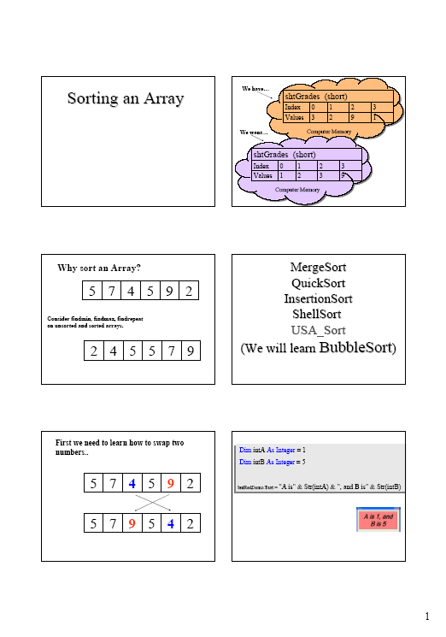

Text: While I teach mostly from my own slides, the following book is the official course text.

MATLAB Demystified by David McMahon

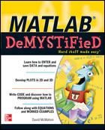
Info about the lab

Our lab staff do an amazing job, with very limited resources. I am anxious that we don’t do anything to make their life more difficult. Please follow all posted signs and directions, and all verbal instructions. Do not use the lab machines to do non-CS005 activities.

CS accounts
You will need to obtain a CS account on the first day, the TA will help you.

Printing in Lab:
You can print for free in lab. Please think carefully before printing to avoid waste. If you print materials that are not relevant to this class (your history homework etc), you will have your grade lowered by one letter.

Open Labs:
Lab schedules are normally posted on lab doors after the beginning of the quarter - an “open” lab is any lab with no scheduled lab section. Additionally, 226 is available as an open lab. In addition, the science library has machines with Matlab installed.

Getting your account
http://csedept.cs.ucr.edu/account/new_account/
This web page is only accessible from within the Computer Science network. So, at the beginning of your lab section, the TA will log and then have students provide their SID, permpin, and birthdate to obtain their account information. Both will show up in bright red letters on the screen. You should make sure they have this information, and then use it to go and log in to a computer.
What sorts of problems can happen, and what should you do about it?
Most students will be fine, but there are specific sorts of exceptions that can occur. The following should cover almost everything, and most of it is things you can do yourself, so please pay careful attention to this section.
(a) They don't know their student information. Typically, they don't know either their permpin or SID. If they are first year students in Fall quarter, they should be able to look these up on the MyUCR site, here:http://cnc.ucr.edu/iguide/sid.html
If they have been at UCR longer, but still don't know their permpin, they can call the Registrar's Office at (951) 827-7284.
(b) They just added the course in the last day. Updates are daily, so they can either wait until the next day or go to walk-in hours for our staff (more on this in (4)(b) below).
(c) They obtain their login and password but claim it doesn't work. With a very few exceptions, this claim is almost always because they are typing it wrong. Have them log in to the CS website via the link on the left hand side of the page, by using the username that they obtained and copy-pasting the password that they obtained. If that works, then their account works, and they are typing their password incorrectly - once they know this, it should be resolvable.
(d) They are in a CS related major but forgot their password. Please have them email systems@cs.ucr.edu requesting a password reset from their UCR account, and we will help them.
(e) They are extension students. See below.
(f) They are having a hard time entering their information in properly. If a student can't obtain their information but are sure they enrolled in the class weeks ago and know their student information, please have them try at least a few times and verify their student information if possible. There is a surprising number of cases for which this solves their problem!

(4) If all of the above fails or the student has some sort of exceptional problem, how can a student get help?
==============================================================
(a) Either you or they can email systems@cs.ucr.edu with a description of the problem. We'll be able to help much more effectively if you (or they) let us know what they've tried. We will either fix the problem or arrange an appointment to meet with them if it's not something that could be handled in email.
(b) You can attend walk-in hours in EBU II, room 105 between 2-4 PM M-F. Please note that we are very short staffed this quarter, and won't be able to handle walk-ins at random times! If they cannot make it to the walk-in time, they can email requesting an appointment as in (4)(a) above.

Extension students only:
Due to how the University handles extension students, extension students are NOT ENROLLED for at least the first two weeks of the course. Since they may still need to complete coursework during those weeks so that they don't fall behind in courses, we will obtain information from BCOE Student Affairs on which Extension students have filled out their paperwork, and provide account information for those students to your instructors for them to distribute at their discretion (they could do this themselves, or delegate to you). We will obtain this information and then provide it to instructors on 9/30 and 10/7. So, to rephrase: Extension students fill out their paperwork, and they obtain account information through the instructors. They do not use the web interface.

