Name (print)  If you want, you can do the homework in teams of two. Both of you get the same grade. Both you should each question together, do not divide up the work. |  | SID
Name (print) |  | SID
What value is assigned to ans in the code below. I have done the first two for you.
 | Write here |  | Write here
>> ans = 1 < 10; | 1 | >> ans = 1 > 10; | 0
>> ans = 1 < 1; |  | >> ans = 1 <= 1;
>> ans = 1 < 1.5; |  | >> ans = 1 < round(1.5);
>> ans = 1 < min(1,999); |  | >> ans = 1 < min(1,inf);
>> 1 <= min(1,inf); |  | >> ans = 1 < 2 + rand;
>> kermit = 5;  >> ans = kermit < 5 |  | >> kermit = 5;  >> ans = kermit <= 5
>> kermit = 11;  >> ans = kermit < kermit |  | >> kermit = 55;  >> ans = kermit == kermit
>> kermit = 5;  >> ans = kermit ~= kermit |  | >> kermit = 5;  >> ans = kermit ~= kermit^2
>> kermit = 5;  >> piggy = 2;  >> ans = kermit == piggy |  | >> kermit = 5;  >> piggy = 2;  >> ans = kermit ~= piggy
>> kermit = 5;  >> piggy = 2;  >> ans = kermit <= piggy |  | >> kermit = 5;  >> piggy = 2;  >> ans = kermit >= piggy
>> kermit = 5;  >> piggy = 2;  >> ans = kermit+ piggy <= Inf |  | >> kermit = 25;  >> piggy = 21;  >> ans = kermit + piggy <= Inf
>> kermit = 59;  >> piggy = 27;  >> ans = kermit+ piggy <= 85 |  | >> kermit = 59;  >> piggy = 27;  >> ans = kermit+ piggy == 82

What of the following are Legal function names that we could make up and use, and which are Not? I have done the first two for you.
 | Write here |  | Write here
MyMaxOfSevenNumbers | L | At Swim two birds | N
AtSwimtwobirds |  | Sues Max of Seven
MyMaxOfSeven#s |  | _My_MaxOf_Seven
At_Swim_two_birds |  | 4x
Fork thine |  | MyMaxOfSevenNums
isAnOddNum? |  | if
Never^at |  | Never^@
MyMaxOf7Numbers |  | N_o_T
X4 |  | 4_x

Look at the following function I wrote: It does exactly what the build in function max does.
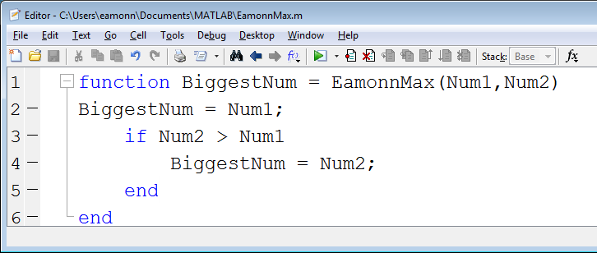
What value is assigned to ans in the code below. In some cases the answer may be “Error: Unexpected MATLAB expression.” I have done the first one for you.
 | Write here |  | Write here
>> ans = EamonnMax(12,2) | 12 | >> ans = EamonnMax(2,2)
>> ans = EamonnMax(-12,-2) |  | >> ans = round( EamonnMax(2) )
>> ans = EamonnMax(2,3,4) |  | >> ans = EamonnMax(2,3,4,1)
>> kermit = 59;  >> piggy = 27;  >> ans = EamonnMax(kermit,piggy) |  | >> kermit = 9;  >> ans = EamonnMax(kermit,10)
>> kermit = 7;  >> piggy = EamonnMax(11,8)  >> ans = EamonnMax(kermit,piggy) |  | >> kermit = 17;  >> piggy = EamonnMax(-18, kermit)  >> ans = EamonnMax(kermit,piggy)
>> kermit = Inf;  >> piggy = EamonnMax(-Inf,8)  >> ans = EamonnMax(kermit,piggy) |  | >> kermit = round(7.1);  >> piggy = round(7.9);  >> ans = EamonnMax(kermit,piggy)
>> GOD = EamonnMax(123,321)  >> ans = EamonnMax(G O D,789) |  | >> fish = round(EamonnMax(1.2,0))  >> ans = EamonnMax(fish,0)

Look at the following function I wrote: It does something...
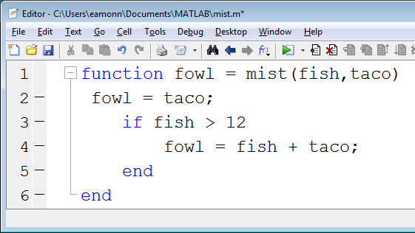
What value is assigned to ans in the code below. In some cases the answer may be “Error: Unexpected MATLAB expression.”
 | Write here |  | Write here
>> ans = mist(113,2) |  | >> ans = mist(11,2)
>> ans = mist(10,2) |  | >> ans = mist(11,2)
>> ans = mist(10,2,17) |  | >> blue = 12;  >> ans = mist(10,blue,2)
>> blue = 12;  >> ans = mist(blue-8,7) |  | >> blue = 12;  >> ans = mist(blue-8,blue)
>> blue = 11;  >> ans = mist(blue+8,7) |  | >> blue = 11;  >> ans = mist(blue+8,round(10.1))
>> ans = mist(10,7.6) |  | >> ans = round(mist(10,7.6))
>> fish = 111; % Think carefully!  >> ans = mist(1,9) |  | >> taco = 1; % Think carefully!  >> ans = mist(1,4)
>> fowl = 121; % Think carefully!  >> ans = mist(7,1) |  | >> fowl = 121;  >> ans = mist(fowl,fish,taco)

