Cs005 Final Study Guide

For the first eight questions, assume the following variables have been initialized in the matlab workspace:
>> BAge = 12;
>> GAge =7;
>> BName = ‘Joe’
>> GName = ‘joanne’
- What does the expression: BAge + GAge * 2 evaluate to?
A) 38 | B) 26 | C) 2
D) Inf | E) NaN
- What does the expression: BAge + GAge / GAge evaluate to?
A) 13 | B) NaN | C) Inf
D) 2.71 | E) 0
- What does the expression: BAge / (GAge - GAge) evaluate to?
A) “Error” | B) 1 | C) Inf
D) 0 | E) NaN
- What does the expression: (BAge - BAge) / (GAge - GAge) evaluate to?
A) 0 | B) 1 | C) Inf
D) -Inf | E) NaN
- What does the expression: BName(2) == GName(2) evaluate to?
A) 1 | B) 0 | C) ‘o’
D) Inf | E) Error: Expression or statement is incorrect--possibly unbalanced
- What does the expressio: BName(1) == GName(1) evaluate to?
A) 1 | B) 0 | C) ‘J’
D) ‘j’ | E) NaN
- What does the expression: sort(GName) evaluate to?
A) aemGN | B) GNaem | C) GName
D) Error: Expression or statement is incorrect--possibly unbalanced | E) aejnno
- What does the expression: upper(BName) evaluate to?
A) BNAME | B) joe | C) JOE
D) Error: Expression or statement is incorrect--possibly unbalanced | E) jOE
(Expect two new questions on legal variable/function names)
- Which variable name below is legal?
A) 2legit2quit | B) HammerTime | C) M.C.Hammer
D) U Can't Touch This | E) U Cant Touch This
- Which variable name below is legal?
A) Vanilla-Ice | B) @ice | C) @ICE
D) Ice | E) 2Iced

(Expect 5 to 10 question that ask you to trace code with different arguments)
Use the function below to answer the next set of questions.
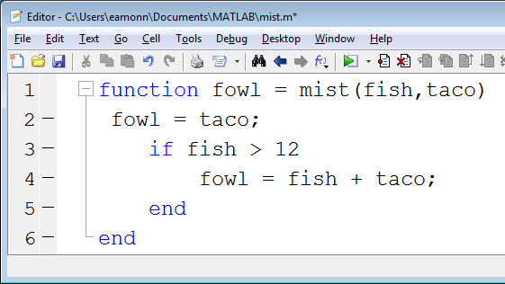
What value is assigned to ans in the code below. In some cases the answer may be “Error: Unexpected MATLAB expression.”
- >> ans = mist(10,10)
A) 10 | B) 20 | C) 100
D) “Error: Unexpected.. | E) NaN
- >> ans = mist(50,10)
A) 10 | B) 20 | C) 50
D) 60 | E) NaN
- >> ans = mist(10,50)
A) 10 | B) 20 | C) 50
D) 60 | E) “fish taco”
- >> ans = mist(13,50)
A) 13 | B) 50 | C) 63
D) “Error: Unexpected.. | E) “taco fish”
- >> ans = mist(floor(12.5),99.5)
A) 12.5 | B) 12 | C) 13
D) 99.5 | E) 99

Expect a question that tests if you understand how to swap to numbers.

***********************************
Look at this code:
>> X = [];
>> X = [X 7];
>> X = [X 7];
What is the value of X now? Expect some questions that test your understanding of this.
**********************************
Look at this code:
>> Y = 3;
>> Y = [2 Y];
>> Y = [Y 9];
What is the value of Y now? Expect some questions that test your understanding of this.

*************************************
Assume that Len holds the length of a string, A.
Look at this loop:
for i = 1 : Len
disp( A(i) );
end
and this loop
for i = 1 : Len
disp( A(Len + 1- i) );
end
What does each string do, say when the string A is ‘fink’
**************************************************
What does this code assign to X?
X = [];
What about this?
X = [1 9];
What about this?
X = [1 : 9];
What about this?
X = [ [1 9] [1 9] ];
What about this?
X = [ [1 2] [ 2 1] [ 1 6] ];
What about this?
X = ['radar' , 'radar'];
What about this?
X = ['radar' , ' ' ,'radar'];
What about this?
X = ['radar' , num2str(17)];

