CS005 Lab 3:

Use good variable names, and comment your code carefully. We will deduct points otherwise.

**Part 1:**

Write a function that gets a person’s driving status. This function is nearly *identical* to the GetVotingStatus function we wrote in lecture. Read the lecture slides again!

Call it EamonnsGetDrivingStatus (but use *your* name)

The function requires no input arguments. It will ask the user how many drinks they had. If the user had three or more drinks, return driving status as **false** (‘0’), otherwise, return a **true** (‘1’).

Test your function, by using some code like the code below.

|  |  |
| --- | --- |
| EDU>> EamonnsGetDrivingStatus()  How Many Drinks did you have : 5  ans =  0  EDU>> EamonnsGetDrivingStatus()  How Many Drinks did you have : 2  ans =  1 | EDU>> IsLegalToDrive = EamonnsGetDrivingStatus();  How Many Drinks did you have : 5  EDU>> if IsLegalToDrive, disp('Here are your keys') , end  EDU>>  EDU>> IsLegalToDrive = EamonnsGetDrivingStatus();  How Many Drinks did you have : 1  EDU>> if IsLegalToDrive, disp('Here are your keys') , end  Here are your keys |

**Part 2:**

Write a function where you pass in two numbers, assumed to be ages of people in years. If the difference between the two numbers is greater than ten, then the function should return true, otherwise return false. Below is how I might use it...

|  |  |
| --- | --- |
| EDU>> LargeAgeDisparity(20,21)  ans =  0  EDU>> LargeAgeDisparity(20,51)  ans =  1 | EDU>> HisAge = 20;  EDU>> HerAge = 48;  EDU>> IsTooGreatAgeDiff = LargeAgeDisparity(HisAge,HerAge);  EDU>> if IsTooGreatAgeDiff, disp('Find someone your own age!'), end  Find someone your own age!  EDU>> |

**Hint**: The function LargeAgeDisparity could be as short as two lines of code, as in my version (I have blurred part of my code deliberately).

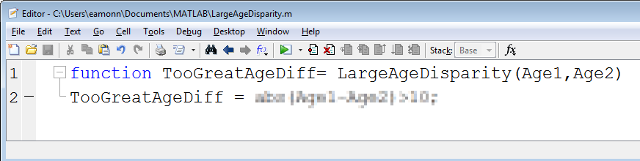

**Part 3:**

Write a function, AmountWithTax, that has an input argument, Purchase, which is the amount of money an item costs. The function should return:

* If the item cost less than $10,000, return Purchase (return the same amount you passed in).
* But if it cost more than $10,000, return the purchase price plus 8%

Test your function carefully. If I passed in 123, it should return 123. If I passed in 20000 it should return 21600 etc

**Part 4:**

Write a function that takes in two numbers. You can assume that they are integers only.

If the two numbers differ by two, return true (‘1’), otherwise return false (‘0’).

|  |  |
| --- | --- |
| EDU>> DifferByTwo(1,5)  ans =  0  EDU>> DifferByTwo(0,2)  ans =  1  EDU>> DifferByTwo(2,0)  ans =  1 | EDU>> DifferByTwo(20,22)  ans =  1  EDU>> DifferByTwo(5,2)  ans =  0  EDU>> DifferByTwo(10,7)  ans =  0 |