CS005 Lab 1
Note that is lab is a very short lab, you should expect to spend the full time (and some time at home) doing future labs.
Part A, this is graded
- Read the slides entitled diary.pptx
- Look up the year of birth and death of your hero (year only, not day and month)
- Look up the number of students, and number of faculty at some university other than UCR (try to pick somewhere different to everyone else, if you look up the university on Wikipedia, the summary box on the right side typically has this info)
OK, you are ready to start the lab.
- First, let us clear the command window, type >> clc and then <enter>
- Turn on the diary, by typing something like this diary('Eamonn4jan2012.txt') you should change the filename to reflect your name, and the date.
- Type a comment that gives your name, student ID and the date, and then <enter>
- Type a comment that says the name of your hero, and then <enter>
- Type a comment that says the year he/she was born and died, and then <enter>
- Type in the equation that gives his/her age at death, and then <enter>
- Type in a comment that gives the name of a University, and then <enter>
- Type in the equation for student to faculty ratio
- Turn the diary off, by typing diary off and then <enter>
- Find your diary file, print it, and hand it to the TA.

Part B, this is NOT graded, but I strongly advise you do it.
Consider all the examples shown in lecture_1_matlab.ppt
Retype them into matlab, and check to see if you get the same results.

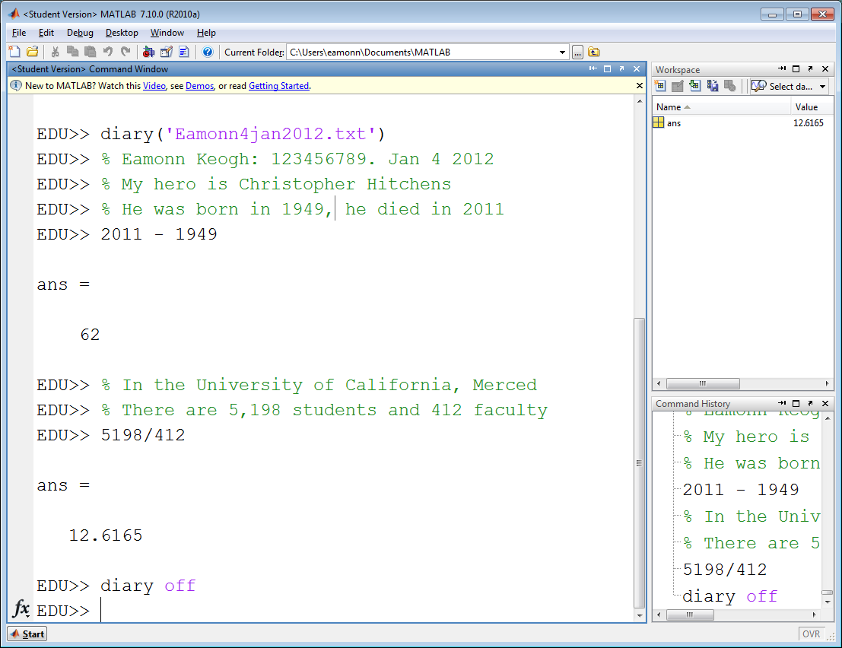 | 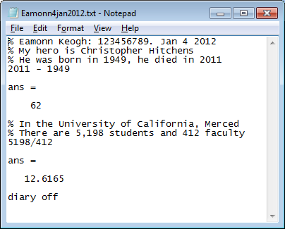  The above figure is the diary, this is what you will print out and hand in.  The figure to the left is a trace of my work that produced the diary.

