Laboratory Exercise – Chapter 3
Calculator

Problem Description:
Develop an application that will perform the basic computations of addition, subtraction, multiplication, and division. This calculator will be very simple in its design. It will contain two text boxes to hold the operands and a series of buttons in between the operands to perform the operation. The result should be stored in a label.

Additionally, add a button that copies the results of the calculation to the first operand and clears the result of the second operand. This will allow the user to easily perform more than one calculation in a row without having to re-enter the last result.

Finally, add a clear all button that clears both operands as well as the result.

Your application should look as follows:

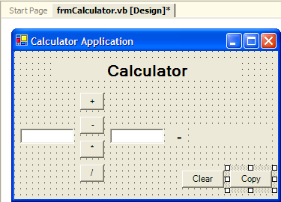

Problem Discussion:
The problem can be broken down into a few tasks.

First you must place all of the controls necessary for the application. This includes:

- 4 buttons to perform the operations (btnAdd, btnSubtract, btnMultiply, and btnDivide)
- two text boxes to store the operands that the operations will be performed upon (txtOperand1 and txtOperand2)
- a label to store the result (lblResult)
- a button to copy the results to the first operand and clear the second operand (btnCopy)
- a button to clear both operands and the results (btnClear)

Next you must add code to each of the buttons. Unfortunately, without certain Visual Basic .NET programming constructs, you cannot develop your calculator to be very robust. For instance, there is no way for you to check to see if the user is attempting to divide by zero. If this occurs, your application will fail. For now, simply ignore this problem. After you complete Chapter 4, you can come back and add code that will prevent this error from occurring.

The code required for the buttons performing the operations should perform the operation on the values contained in the two text boxes. However, the values in the text boxes are stored as Strings, so do not forget to covert them to numerical values before performing the operation.

Problem Solution:

Step 1: Create an application called Calculator.
Step 2: Rename the form in the Solution Explorer to frmCalculator.vb.
Step 3: Change the Name property of the form to frmCalculator.
Step 4: Change the Text property of the form to Calculator Application.
Step 5: Add a label control to the form.
Step 6: Change the Name property of the label to lblTitle.
Step 7: Change the Text property of the label to Calculator.

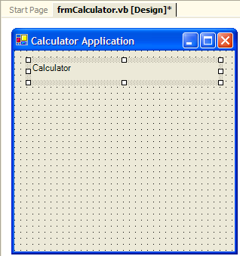

Step 8: Change the TextAlign property of the label to MidddleCenter.

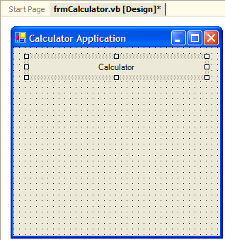

Step 9: Change the Font Size to 16 and the Bold property to True.

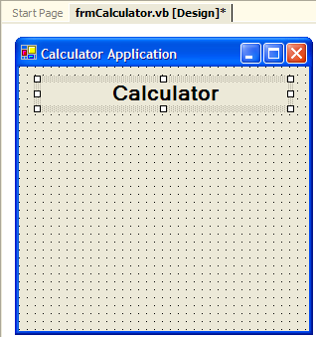

Step 10: Add a text box for the first operand.
Step 11: Change the Name property of the text box to txtOperand1.
Step 12: Clear the Text property of the text box.

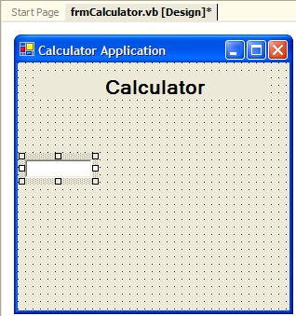

Step 13: Add a text box for the second operand.
Step 14: Change the Name property of the text box to txtOperand2.
Step 15: Clear the Text property of the text box.

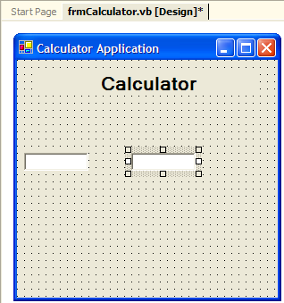

Step 16: Add a button for each operation: Addition, Subtraction, Multiplication, and Division.
Step 17: Change the Name property of the buttons to btnAdd, btnSubtract, btnMultiply, and btnDivide,
Step 18: Set the Text property of the buttons to +, -, *, and /.

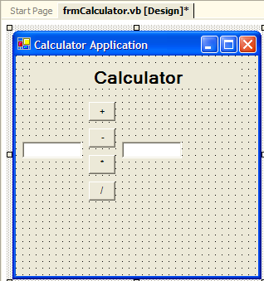

Step 19: Add a label to display an equals sign.
Step 20: Change the Name property of the label to lblEqual.
Step 21: Set the Text property of the label to =.

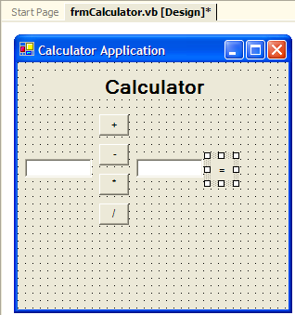

Step 22: Add a label for the result.
Step 23: Change the Name property of the label to lblResult.
Step 24: Clear the Text property of the label.
Step 25: If you need to make the form bigger, resize the form so that text box can be created large enough to fit. Also, you can reduce the height of the form, because all of the space will not be needed.

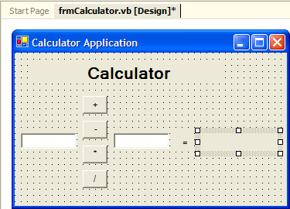

Step 26: Center the lblTitle label so that it is positioned properly.

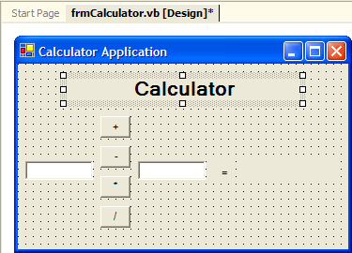

Step 27: Add a button to clear the contents of the calculator.
Step 28: Change the Name property of the button to btnClear.
Step 29: Set the Text property of the button Clear.

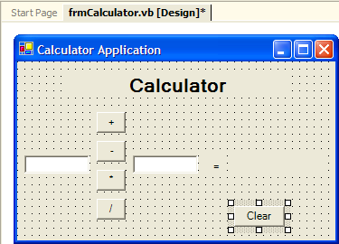

Step 27: Add a button to clear the contents of the calculator.
Step 28: Change the Name property of the button to btnCopy.
Step 29: Set the Text property of the button Copy.

Step 30: Add the code for the first button, btnAdd, to perform the addition. The code should declare variables to store each of the operands, copy the values from the text boxes to the variables, perform the addition, store the result in a variable, and copy the result back to the lblResult label.

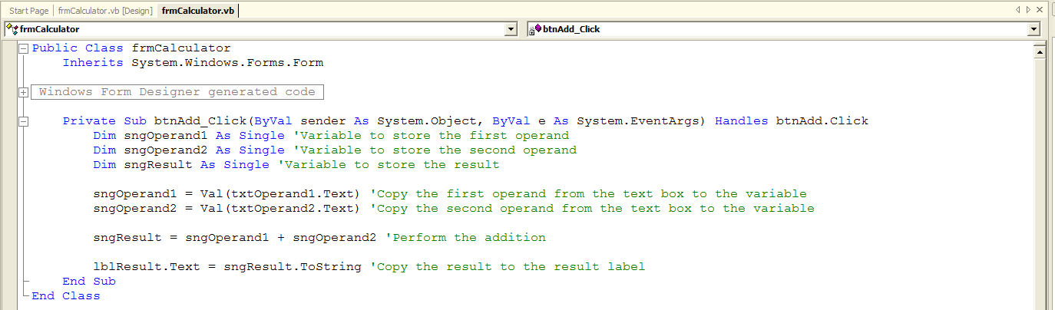

Step 31: Add the code for the first button, btnSubtract, to perform the addition. The code should declare variables to store each of the operands, copy the values from the text boxes to the variables, perform the subtraction, store the result in a variable, and copy the result back to the lblResult label.

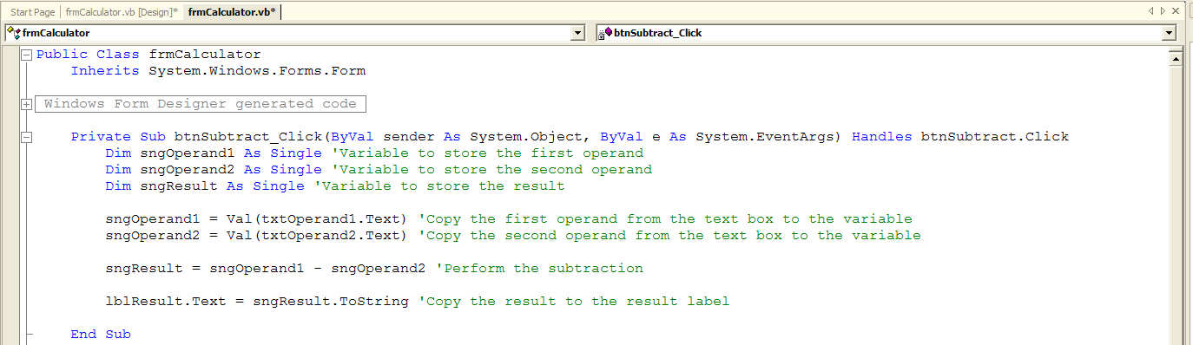

Step 32: Add the code for the first button, btnMultiply, to perform the addition. The code should declare variables to store each of the operands, copy the values from the text boxes to the variables, perform the multiplication, store the result in a variable, and copy the result back to the lblResult label.

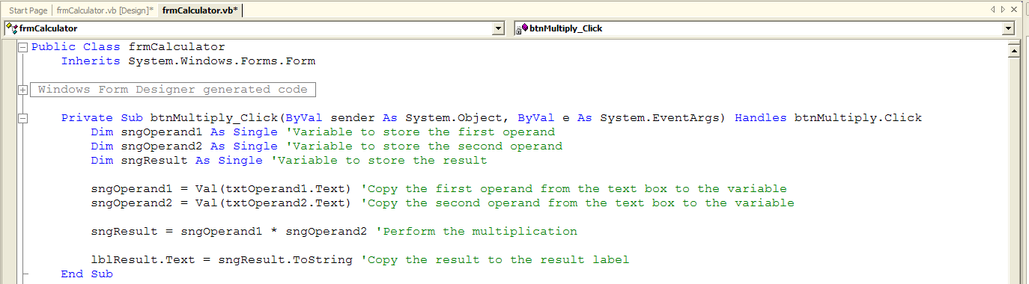

Step 33: Add the code for the first button, btnDivide, to perform the addition. The code should declare variables to store each of the operands, copy the values from the text boxes to the variables, perform the division, store the result in a variable, and copy the result back to the lblResult label.

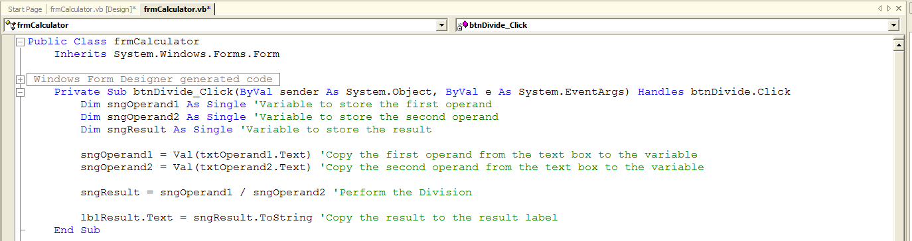

Step 34: Add the code for the button, btnClear, to remove any values from the operand text boxes, txtOperand1 and txtOperand2, as well as the result label, lblResult.

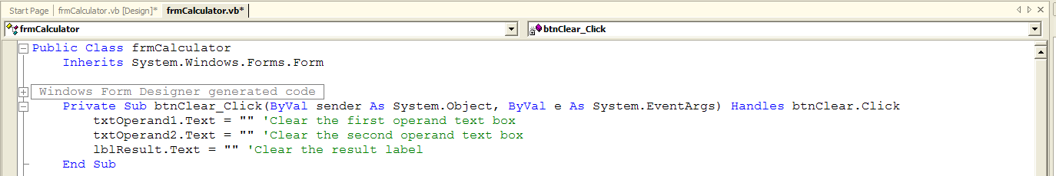

Step 35: Add the code for the button, btnCopy, to copy the value in the result label, lblResult, to the first operand. Clear the value in the second operand text boxes, txtOperand2, as well as the result label, lblResult.

