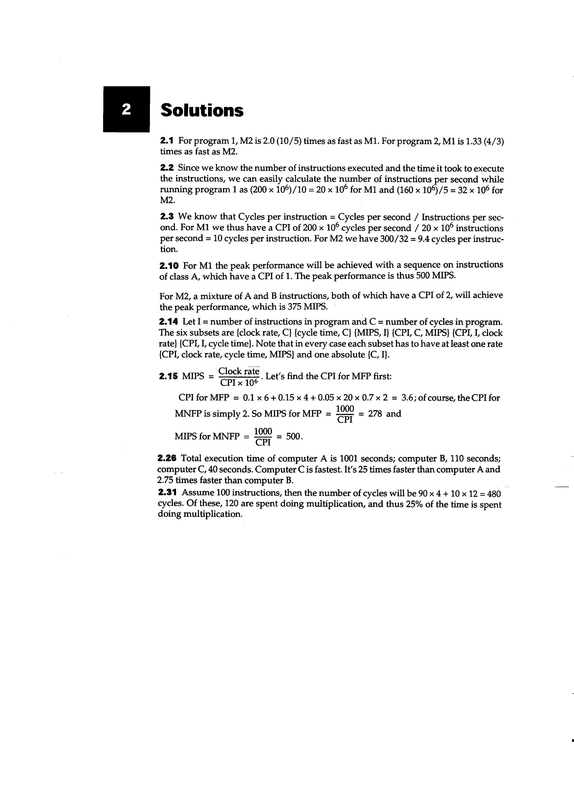
2.13 Using C1, the CPI on M1 = 5.8 and CPI on M2 = 3.2. Because M1 has a clock rate twice as fast as that of M2, M1 is 1.10 times as fast. Using C2, the CPI on M1 = 6.4 and CPI on M2 = 2.9. M2 is (6.4/2)/2.9 = 1.10 times as fast. Using a third-party product, CPI on M1 = 5.4 and on M2 = 2.8. The third-party compiler is the superior product regardless of machine purchase. M1 is the machine to purchase using the third-party compiler, as it will be 1.04 times faster for typical programs.

2.18 CPI for Mbase = 2x0.4 + 3x0.25 + 3x0.25 + 5x0.1 = 2.8
CPI for Mopt = 2x0.4 + 2x0.25 + 3x0.25 + 4x0.1 = 2.45

